

Internet Software Architecture

(4CS017)

# 

Student Id : NP03CS4S230066 (2358866)

Student Name : Prajal Tulsi

Group : L4CG4

Lecturer : Mr. Yamu Poudel

Tutor : Mr. Karan Shrestha

Submission Date : June 9, 2023

# 

# Question

Make a simple interest calculator using javascript.

# Code

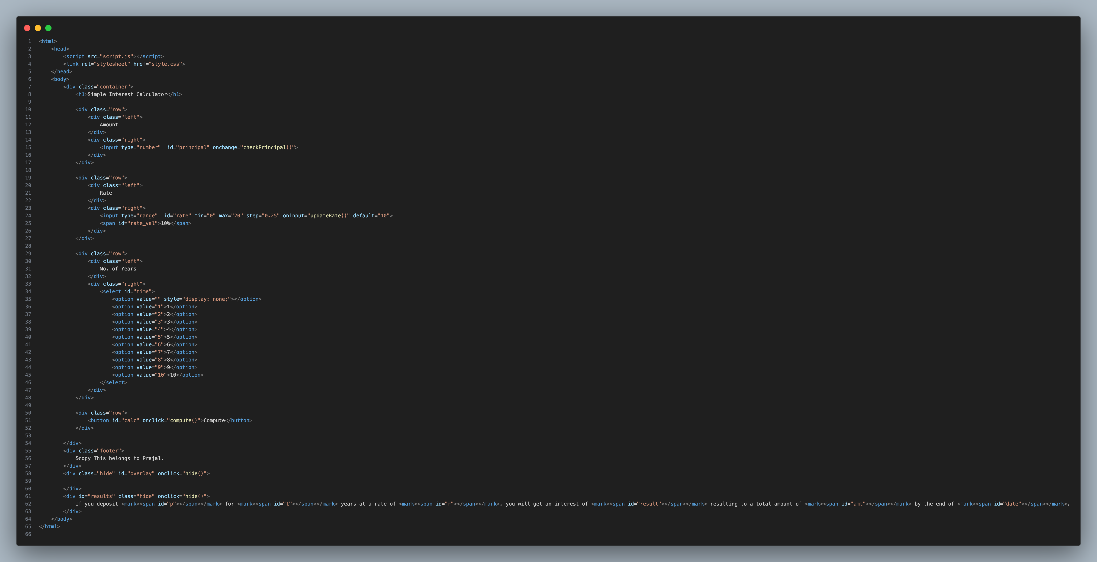

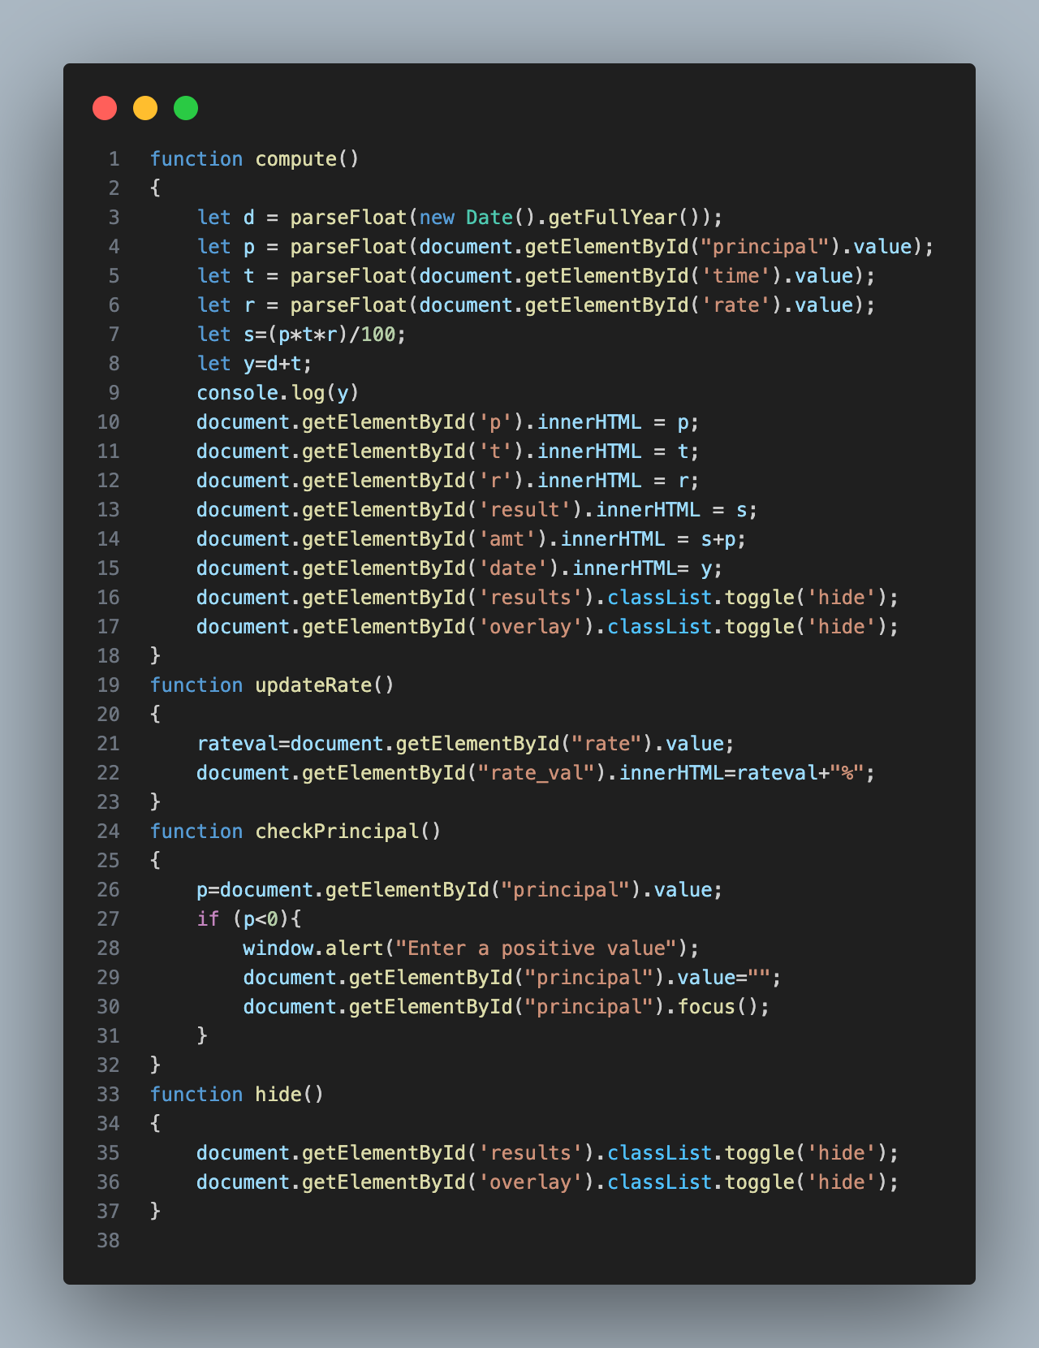

# Output

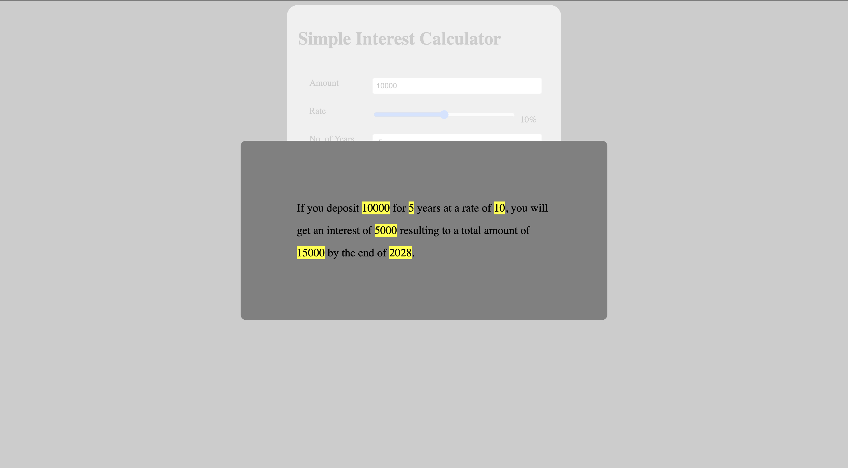

# Learning outcomes and Conclusion

In this program I learned to use toggle class. I also learned to use different element selectors in JavaScript and learned to manipulate different elements of the function. I also learned how to get the current date and manipulate the data accordingly. In addition to that, I learned about the different data types in JavaScript and how it reacts to different data types. I also learned about z-index and overlays which allowed me to create a better design for my code.

Hence, this was a fun program to do, and it helped me refresh my knowledge about JavaScript and also helped me learn new things. I enjoyed doing the project overall.